Skyline Glow Ball Fun Night
SATURDAY, SEPT.11TH PM 8PM REGISTRATION
$40/ Person $20/ Member W/Cart
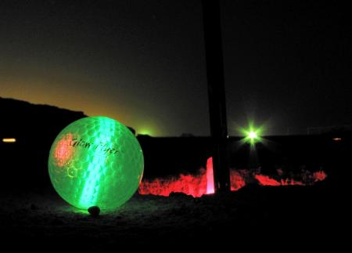

EntryFee
Entry fee includes golf, cart, 2 drink tickets, glow balls, and a good time.

